FINAL PROJECT REPORT
STUDENT SUBJECT SELECTION SYSTEM
0/1 Knapsack and Dynamic Programming Based Academic Optimization

Project objective: Help students select electives under credit, workload and preference constraints while making the optimization decision explainable.

Cover Detail | Information
Student Names & Roll Numbers | V JASHWANTH / Roll No. 25MVCSMR0704  K SHIVAKUMAR / Roll No.25MVCSMR0649  K MANI CHANDRA / Roll No.25MVCSMR0687  CH NARENDAR / Roll No.25MVCSMR0638

Core Technologies: Python • Flask • SQLite • Bootstrap

Table of Contents
Section | Title
1 | Abstract & Introduction
2 | Problem Statement, Objectives & Scope
3 | Features & Functional Requirements
4 | Algorithms & Methodology
5 | Technologies & Implementation
6 | Results, Testing & Performance
7 | Conclusion, Future Scope & References

Report note: This document describes the submitted prototype and distinguishes implemented functionality from proposed/future functionality. Any numerical result not measured from a live deployment is labeled as illustrative.

1. Abstract & Introduction

1.1 Abstract
The Student Subject Selection System is a web-based academic decision-support prototype designed to help students choose elective subjects under credit and workload limits while maximizing a preference score. The system combines a college-style portal with an algorithmic optimization layer. Student information such as department, year, CGPA, interests, and skills is stored in SQLite. Subject information includes credits, workload, preference score, minimum CGPA, and seat availability. Eligible elective subjects are scored against the student profile and passed to a two-resource 0/1 Knapsack Dynamic Programming optimizer.
The main contribution of the project is explainability. Instead of returning only a list of subjects, the prototype exposes the constraints used, the resulting preference score, the selected subjects, and the amount of credit/workload capacity consumed. Dynamic Programming stores the best score for previously solved resource states and predecessor information is used to reconstruct the final selection. This makes the project suitable for demonstration in a Design and Analysis of Algorithms (DAA) context as well as an academic management application.

1.2 Introduction
Elective selection is a constrained decision problem. Students may need to satisfy a semester credit limit, balance workload, meet eligibility rules, and still choose subjects that align with academic interests or career goals. As the number of available subjects increases, the number of possible combinations grows rapidly. A portal that simply lists subjects does not solve this optimization problem; it only transfers the decision burden to the student.
This project addresses that gap by treating each elective as a candidate item. A subject can either be selected or not selected, which directly matches the 0/1 Knapsack model. The prototype adds a second resource dimension - workload - so the optimization state is represented by both credit capacity and workload capacity. Mandatory subjects are handled separately and are shown to the student rather than being silently mixed with elective optimization.

1.3 Purpose of the Project
- Provide a centralized portal for student and subject information.
- Filter subjects using department, CGPA and seat-availability conditions.
- Generate a personalized preference score from the student profile.
- Select an optimal feasible elective combination using 0/1 Knapsack with Dynamic Programming.
- Present the algorithmic decision in a form that is understandable to the user.
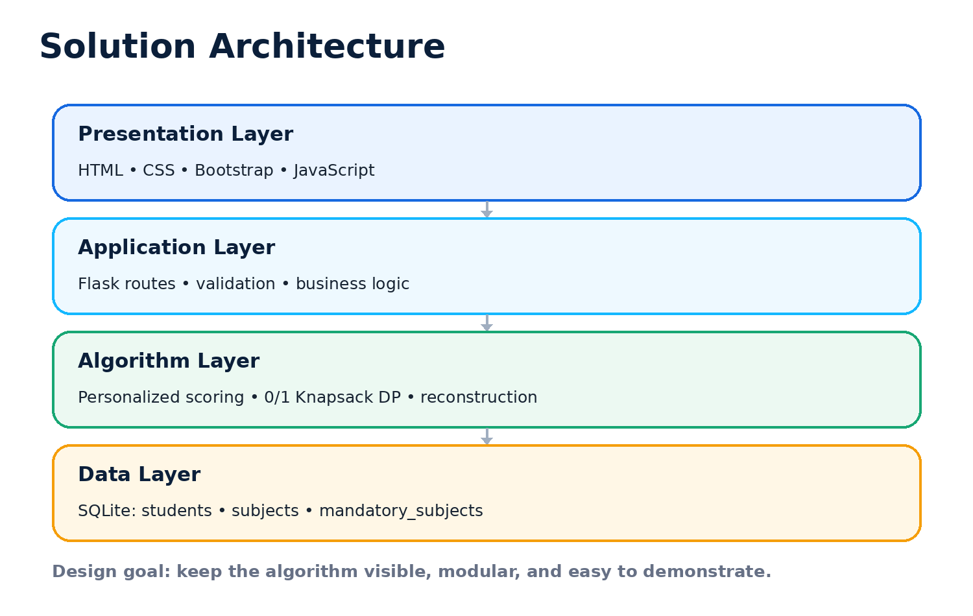
Figure 1. Solution architecture of the proposed system.

2. Problem Statement, Objectives & Scope

2.1 Problem Statement
Help students select electives under credit, workload and preference constraints. The system must maximize academic preference score while satisfying mandatory rules. The challenge requires the prototype to represent the relevant entities and resource values, perform optimization, and expose enough intermediate decision information to explain why the final combination was chosen.

2.2 Project Objectives
- Maximize the stated value, benefit, coverage, capacity, score, or reward represented by the student preference score.
- Demonstrate 0/1 Knapsack and Dynamic Programming as the primary DAA contribution.
- Reconstruct and display the selected subjects instead of returning only the objective value.
- Apply eligibility and mandatory-subject rules before or alongside optimization.
- Provide a practical web interface that connects academic data management with algorithmic decision making.

2.3 Scope
In Scope | Description
Student profiles | Create and view student information including CGPA, interests and skills.
Subject catalogue | Store and display subject details such as credits, workload, preference score and eligibility.
Optimization | Two-resource 0/1 Knapsack DP for elective selection.
Explainability | Show selected subjects, total credits, workload and objective score.
Basic validation | Unique roll numbers, required fields and numeric validation.
SQLite storage | Local database without a separate database server.

2.4 Target Users
- Students who need assistance in choosing electives.
- Academic coordinators who want a transparent constraint-aware selection process.
- Project evaluators who need to see a practical DAA implementation.
- Future administrators who may extend the portal into a larger academic management platform.

2.5 Assumptions and Constraints
- Subjects are independently selectable electives; prerequisite relationships are outside the current prototype scope.
- Mandatory subjects are identified by department and year and displayed separately from the elective optimization.
- The current scoring method uses lightweight keyword matching against interests/skills plus a CGPA suitability adjustment.
- The prototype is intended for local/demo deployment; production-grade authentication, concurrency, and cloud deployment are future work.

3. Features & Functional Requirements

3.1 Main Features
Feature | Function
Dashboard | Shows student count, subject count, department count, average CGPA and recent students.
Student Profiles | Stores roll number, name, department, year, CGPA, interests and skills.
Subject Catalogue | Stores code, name, department, category, credits, workload, preference score, minimum CGPA, seats and description.
Personalized Scoring | Adjusts base subject score using profile-interest/skill matches and CGPA suitability.
Optimization | Runs two-resource 0/1 Knapsack DP using credits and workload constraints.
Decision Reconstruction | Backtracks stored predecessor states to identify selected subjects.
Explainable Result | Reports selected subjects, objective score and resource usage.
Input Forms | Allows creation of students and subjects with basic validation.

3.2 Functional Requirements
ID | Requirement | Description
FR-01 | Create student profile | The system shall accept and store valid student details.
FR-02 | Create subject | The system shall accept subject credit, workload, score and eligibility data.
FR-03 | View profiles | The system shall display student and subject data in a readable interface.
FR-04 | Filter eligibility | The optimizer shall consider matching department, sufficient CGPA and available seats.
FR-05 | Optimize electives | The system shall perform 0/1 DP for the given credit/workload limits.
FR-06 | Reconstruct decision | The system shall show which electives were selected from stored DP states.
FR-07 | Explain output | The system shall show score, credits, workload and constraint usage.
FR-08 | Validate input | The system shall reject invalid numeric data and duplicate roll numbers.
FR-09 | Mandatory rules | The system shall identify mandatory subjects for department/year and display them separately.

3.3 CRUD Operations
The prototype currently supports the Create and Read parts of CRUD for core student and subject entities. Update and Delete operations are not part of the current minimal implementation and are identified as extension work. This distinction is important for accurate project documentation.
CRUD Operation | Current Prototype | Status
Create | Add Student / Add Subject | Implemented
Read | Dashboard, profiles, catalogue, results | Implemented
Update | Edit existing record | Planned
Delete | Remove existing record | Planned

3.4 Authentication & Validation
The current prototype is a local academic demonstration and does not implement user login. Input validation is performed through required fields, numeric conversion and SQLite uniqueness for student roll numbers. Role-based authentication and authorization are proposed for a production deployment.

3.5 System Requirements
- Python environment capable of running Flask.
- Modern web browser such as Chrome, Edge or Firefox.
- VS Code or another Python IDE for development.
- SQLite database file for local persistence.
- Internet access is not required for the core local prototype once dependencies are installed.

4. Algorithms & Methodology

4.1 System Workflow
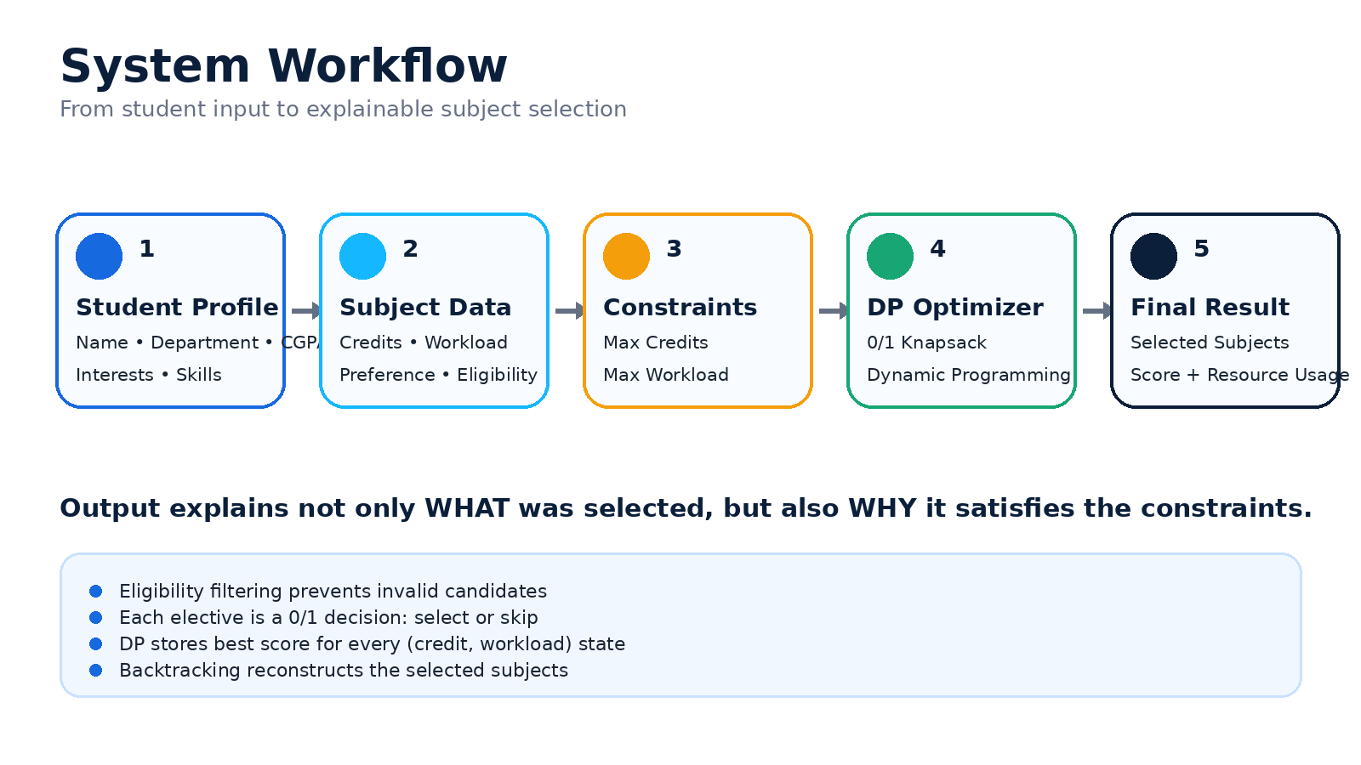
Figure 2. End-to-end system workflow.

4.2 0/1 Knapsack Formulation
For each elective subject i, define: c_i as the credit cost, w_i as the workload cost, and v_i as the personalized preference value. A decision variable x_i ∈ {0,1} indicates whether the subject is selected. With maximum credit capacity C and maximum workload capacity W, the objective is to maximize Σ v_i x_i subject to Σ c_i x_i ≤ C and Σ w_i x_i ≤ W.

4.3 Dynamic Programming State and Recurrence
The prototype uses a two-dimensional resource state. DP[c][w] stores the best preference score achievable using at most c credits and w workload units. For a current subject with credit c_i, workload w_i and value v_i, the transition is:
DP[c][w] = max( DP[c][w], DP[c-c_i][w-w_i] + v_i ) when c ≥ c_i and w ≥ w_i.
The inner loops iterate from higher capacities toward lower capacities. This reverse traversal is a standard implementation technique for enforcing the 0/1 property within a single DP layer: a subject cannot be reused multiple times in the same iteration.

4.4 Decision Reconstruction
- Find the resource state with the highest DP value within the allowed credit and workload limits.
- Use the stored predecessor information to identify the subject that produced the state improvement.
- Move to the predecessor state and repeat until the origin is reached.
- Reverse the recovered list to obtain the selected-subject order.
- Calculate total credits and total workload from the reconstructed set for verification.
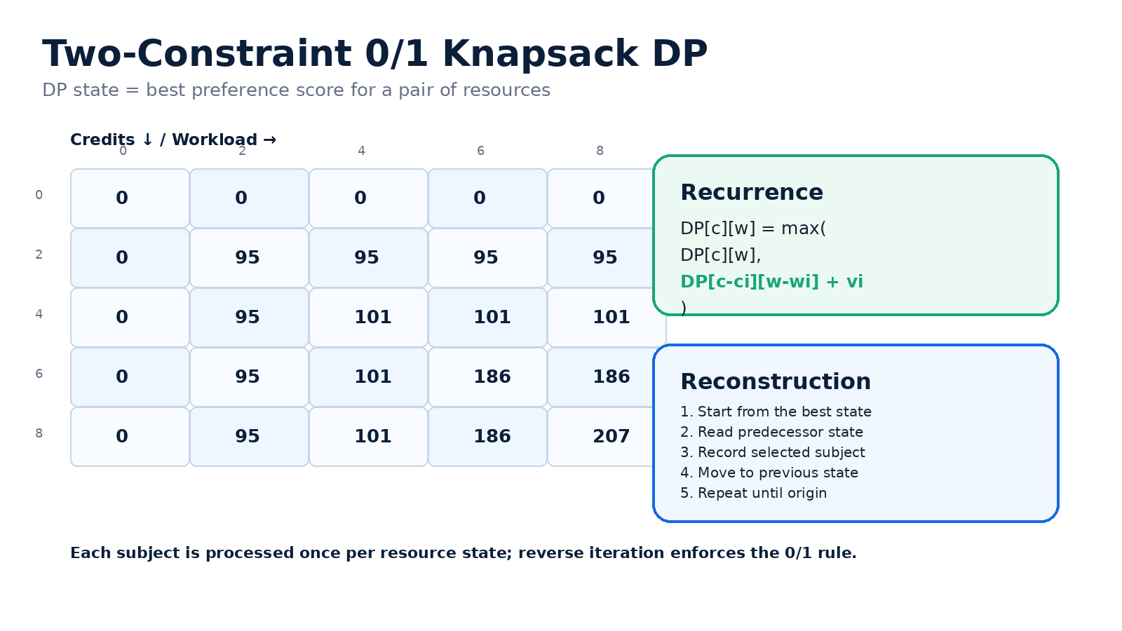
Figure 3. Illustrative DP state table and reconstruction logic. Values are explanatory, not benchmark measurements.

4.5 Personalized Preference Score
Each eligible subject begins with its stored base preference score. The prototype then applies a lightweight profile-matching bonus when student interests or skills match subject text/categories, followed by a small CGPA suitability adjustment. The purpose is not to build a machine-learning model, but to convert student profile information into a transparent optimization value that can be explained during a DAA demonstration.

4.6 Methodology
- Requirement analysis: identify students, subjects, constraints and mandatory rules.
- Data modelling: represent core entities in SQLite tables.
- Algorithm design: formulate elective selection as 0/1 Knapsack with two resource limits.
- Implementation: integrate DP with Flask routes and HTML templates.
- Validation: verify eligibility, constraints, reconstruction and user-facing result presentation.
- Iteration: refine UI and explainability for hackathon demonstration.

5. Technologies & Implementation

5.1 Technology Stack
Technology | Purpose
Python | Backend programming language and application logic.
Flask | Lightweight web framework for routing, templates, form handling and integration.
SQLite | Embedded relational database for students, subjects and mandatory-subject mappings.
HTML / CSS | Page structure, styling and responsive visual design.
Bootstrap | Responsive layout components and interface utilities.
JavaScript | Client-side interactions and visual enhancements.

5.2 Architecture and Components
Figure 4. Four-layer implementation architecture.

5.3 Database Design
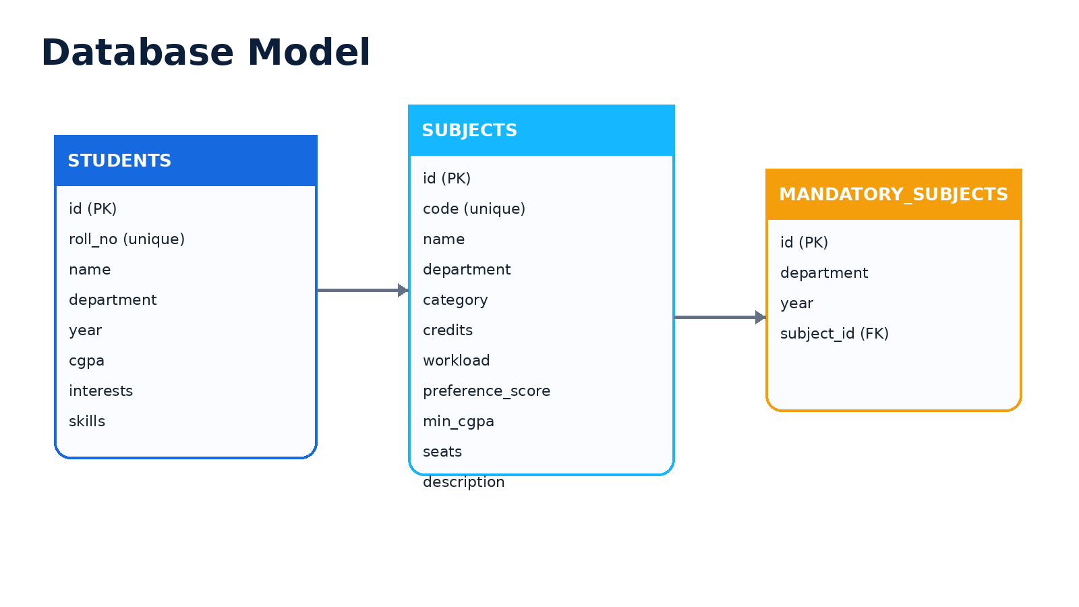
Figure 5. Simplified database model used by the prototype.

5.4 Core Tables
Table | Key Fields | Role
students | id, roll_no, name, department, year, cgpa, interests, skills | Stores student profile information.
subjects | id, code, name, department, category, credits, workload, preference_score, min_cgpa, seats | Stores subject resources, value and eligibility.
mandatory_subjects | id, department, year, subject_id | Maps mandatory subjects for a department/year.

5.5 Implementation Details
- The Flask application creates the SQLite schema automatically when first launched.
- Demo seed data is inserted only when the relevant tables are empty.
- Eligibility is filtered using department, CGPA and positive seat availability.
- The personalized scoring function is deterministic, making the demo result repeatable for the same data.
- The optimization function maintains a DP matrix indexed by credit and workload, plus a predecessor matrix for reconstruction.
- Templates separate presentation from Python logic, allowing the UI to be redesigned without rewriting the algorithm.

5.6 Representative Code Logic
# Two-resource 0/1 Knapsack transition
for item in scored_subjects:
c = item["credits"]
w = item["workload"]
v = item["personalized_score"]
for credit in range(max_credits, c - 1, -1):
for work in range(max_workload, w - 1, -1):
candidate = dp[credit-c][work-w] + v
if candidate > dp[credit][work]:
dp[credit][work] = candidate
chosen[credit][work] = (item, credit-c, work-w)
The reverse iteration over both resource dimensions ensures each subject contributes at most once to a DP state, preserving the 0/1 selection rule.

6. Results, Testing & Performance

6.1 Project Results
The implemented prototype provides the main algorithmic path required by the challenge: student profile input, subject eligibility filtering, personalized scoring, two-constraint 0/1 Knapsack DP, decision reconstruction, and an explainable result page. The application also includes local SQLite persistence and web pages for the dashboard, student list, student profile, subject catalogue, and input forms.

6.2 Illustrative End-to-End Result
Illustrative example only - replace this section with the exact output captured from the final live run during submission.
Field | Illustrative Value
Student | Rahul Sharma (CSE, Year 3, CGPA 8.7)
Optimization limits | Maximum 8 credits; maximum 14 workload units
Selected electives | Artificial Intelligence; Data Science
Elective credits used | 7
Elective workload used | 13
Illustrative preference score | 207
Mandatory subject | Cyber Security - displayed separately for CSE Year 3

The example above is derived from the seeded demonstration dataset and the current scoring/DP logic. It is included to show how a result can be documented; it should not be described as a measured performance benchmark.

6.3 Test Cases
Test ID | Scenario | Expected Result
TC-01 | Valid student profile | Student is created and appears in student list.
TC-02 | Duplicate roll number | Creation fails and a validation message is shown.
TC-03 | Ineligible subject by CGPA | Subject is excluded from eligible elective candidates.
TC-04 | Subject with no seats | Subject is excluded from optimization candidates.
TC-05 | Credit capacity reached | Returned combination does not exceed maximum credits.
TC-06 | Workload capacity reached | Returned combination does not exceed maximum workload.
TC-07 | Mandatory subject mapping | Mandatory subject is shown for the appropriate department/year.
TC-08 | DP reconstruction | Selected subjects match the predecessor path stored during optimization.

6.4 Testing Methods
- Functional testing of routes, forms and output pages.
- Boundary testing using low and high credit/workload limits.
- Validation testing for numeric and uniqueness constraints.
- Algorithm verification using small hand-checkable subject sets.
- UI testing at common desktop/mobile widths for readability and responsiveness.

6.5 Performance Analysis
With n eligible elective subjects, C maximum credits and W maximum workload, the two-resource DP uses O(n × C × W) time and O(C × W) DP storage, plus predecessor storage of the same order for reconstruction in the current implementation. This is practical for small-to-medium academic subject catalogues when credit and workload capacities remain relatively small. The dominant factor is the size of the resource state space, not the total number of possible subject combinations.
Approach | Decision Quality | Typical Complexity | Role in Project
0/1 Knapsack + DP | Optimal for the modeled constraints | O(n × C × W) | Primary algorithmic solution
Greedy heuristic | May be fast but can miss the optimum | Approximately O(n log n) for sorting + scan | Useful as a reference comparison, not the final optimizer

6.6 Practical Impact
- Reduces manual trial-and-error when choosing electives.
- Makes credit and workload constraints explicit.
- Connects student interests/skills to a transparent scoring mechanism.
- Provides a clear algorithmic explanation suitable for academic evaluation.
- Creates a foundation for future academic dashboards and mobile/cloud extensions.

7. Conclusion, Future Scope & References

7.1 Conclusion
The Student Subject Selection System demonstrates how a real academic decision can be translated into a classic optimization problem and then embedded inside a practical web application. By representing each elective as a binary choice and defining credits and workload as constrained resources, the problem maps naturally to a 0/1 Knapsack formulation. Dynamic Programming then provides an efficient way to solve overlapping subproblems and reconstruct the final selection.
The prototype goes beyond a numerical algorithm demonstration by integrating the optimizer with student profiles, subject metadata, eligibility conditions and a web interface. This makes the system useful both as a DAA project and as a concept for academic decision support. The primary limitation of the current prototype is scope: authentication, full CRUD administration, prerequisite handling, timetable conflicts, richer preference modelling, and production deployment remain future enhancements.

7.2 Future Scope
- Student, faculty and administrator login with role-based access.
- Full CRUD management for students, subjects and rules.
- Semester-wise selection with prerequisites and timetable conflict detection.
- Richer preference modelling using ranked interests and explicit student weights.
- Attendance/performance-aware recommendations with explainable scoring.
- Analytics dashboard for subject demand, popularity and capacity utilization.
- REST API and mobile application integration.
- Cloud deployment with secure authentication, backups and multi-department scaling.

7.3 Scalability Vision
Single Department → Entire College → Multiple Campuses → Cloud-Based Academic Platform

7.4 Final Takeaway
“From academic information to intelligent subject selection - the system combines a practical student portal with algorithm-driven decision making.”

7.5 References / Documentation
Source | Title / Topic | Reference
Python Software Foundation | Python Documentation | https://docs.python.org/3/
Pallets Projects | Flask Documentation | https://flask.palletsprojects.com/
SQLite Consortium | SQLite Documentation | https://www.sqlite.org/docs.html
Bootstrap Team | Bootstrap Documentation | https://getbootstrap.com/docs/
Cormen, T. H., Leiserson, C. E., Rivest, R. L., Stein, C. | Introduction to Algorithms, Dynamic Programming / Knapsack topics | MIT Press
Project source | Student Subject Selection System Flask + SQLite prototype | Local project implementation

7.6 Submission Checklist
- Replace cover-page placeholders with actual student names, roll numbers, department, college and guide details.
- Insert final website screenshots in the Results section after capturing them from the running prototype.
- Replace the illustrative example result with the exact output from the final demonstration run.
- Attach the source code / project ZIP as the implementation artifact.
- Review the report once more against your college formatting requirements before submission.

Appendix A - Project Structure
student_subject_selection/
├── app.py
├── requirements.txt
├── README.md
├── run.bat
├── static/
│ ├── app.js
│ └── style.css
└── templates/
├── base.html
├── dashboard.html
├── students.html
├── add_student.html
├── student_profile.html
├── algorithm_result.html
├── subjects.html
└── add_subject.html

Appendix B - Viva / Presentation Points
- Why 0/1 Knapsack? Each elective is either selected or not selected.
- Why Dynamic Programming? Many resource states repeat; DP stores their best scores.
- Why two resources? Both credit and workload are explicit constraints in the problem statement.
- How is the result explainable? The system shows the chosen subjects, score and resource usage, and reconstructs the decision from predecessor states.
- What is next? Add prerequisites, timetable conflicts, stronger preference modelling and authenticated multi-role deployment.

